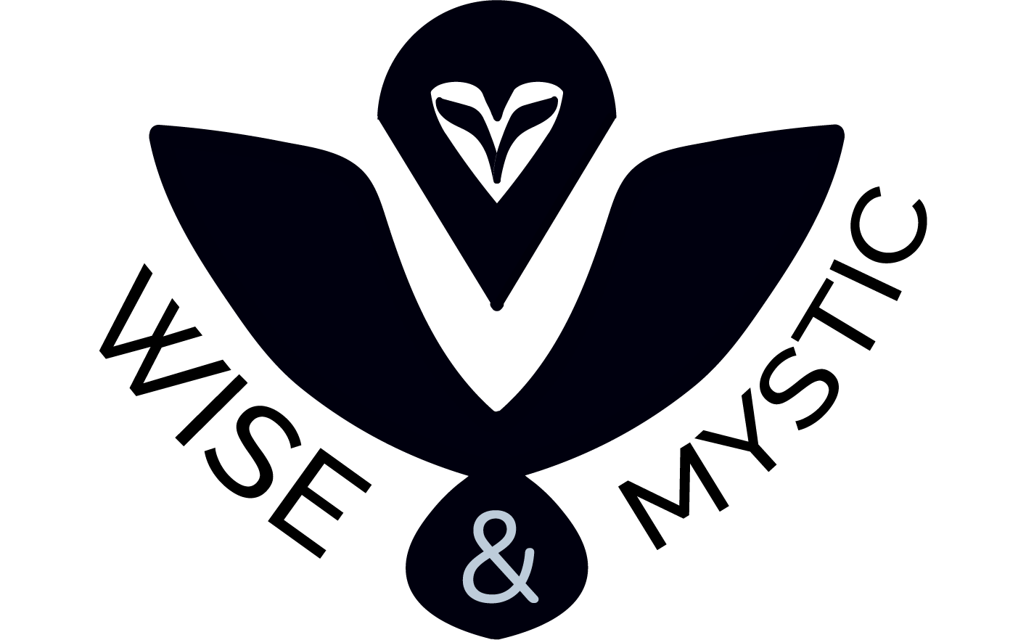

Wise & Mystical

*Test plan*

1. INTRODUCTION 2
   1. QUALITY OBJECTIVE 2
   2. ROLES AND RESPONSIBILITIES 2
2. TEST METHODOLOGY 2
   1. OVERVIEW 2
   2. TEST LEVELS 3
   3. TEST COMPLETENESS 3
3. TEST DELIVERABLES 3
4. RESOURCE & ENVIRONMENT NEEDS 4
   1. TESTING TOOLS 4
   2. TEST ENVIRONMENT 4

1

# Introduction

## Quality Objective

* + - Major bugs or issues are identified and fixed before the presentation of the project

## Roles and Responsibilities

* + - QA Analyst – Make sure the application is working fine and that all the functionalities within it are working without major bugs or issues
    - Scrum trainer – Creating and organizing the GitHub repository of the team including making the main documentation for the project.
    - Backend developers – Creating the application and all the functionalities within it, programming.

# Test Methodology

## Overview

* + - WaterFall – It is a simple but steady method. It makes the tasks organization easier and a total idea about how and what we will have at the end of the project

2

## Test Levels

* + - Unit testing – Makes sure that the application can be executed successfully.
    - Integration testing - Integrating testing checks the data flow from one module to other modules.
    - System testing – Checks if the application fits the requirements given by the customer or a user.
    - Acceptance testing – Done by the customer or a user, checking if the application fits their requirements themselves.

## Test Completeness

* + - 100% test coverage
    - Manual Test cases executed
    - All open bugs are fixed or will be fixed in next release

# Test Deliverables

* Test Plan
* Excel file with description of the test suits, filled with different test cases

3

# Resource & Environment Needs

## Testing Tools

* + - Automatic testing tools have not been used
    - By hand

## Test Environment

* Windows 8 and above
* Office 2013 and above

4